Application for Employment
Position You Are Applying For Desired Salary
Date Available for Work:
 | PERSONAL INFORMATION
 | First Name _________________________________ Last Name _______________________________________ Middle _________________
Address________________________________________________ City ___________________ State______ Zip ____________________
Home Phone:___________________ Cell Phone:___________________ Email address: _______________________________________

Social Security Number: _____________________________________
Are you a U.S. Citizen? [ ] Yes [ ] No
Have you ever been convicted of a felony? [ ] Yes [ ] No
If selected for employment are you willing to submit to a pre-employment drug screening test? Yes | No
If selected for employment are you willing to submit to a background screening? Yes | No
EDUCATION
School Name |  | Location | Years Attended | Degree Received | Major
Other training, certifications or licenses held:

REFERENCES
Name | Title | Company | Phone
Acknowledgement and Authorization
I certify that all answers given herein are true and complete to the best of my knowledge.
I authorize investigation of all statements contained in this application for employment as may be necessary in arriving at an employment decision.
In the event of employment, I understand that false or misleading information given in my application or interview(s) may result in discharge.

Signature of Applicant _____________________________ Date _____________________________
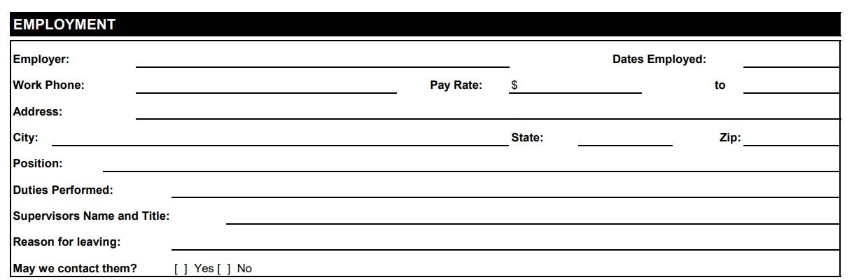
Please attach CV/Resume and Cover Letter when you submit your application.
****************
*Office Use Only: Hired? ______________ Position______________ Start Date_________________

